**Exercise: Design a component in Figma**

**Overview**

In this exercise, you will design a UI button component in Figma. Components are reusable design elements. Think of them as building blocks. Components help give consistency to your designs and allow you to apply adjustments across multiple files and projects rapidly.

Let’s start!

**Step 1**

* Open a new Figma file.
* Create a frame and choose the dimensions of the component you will make. This will be the add-to-order button for a mobile device you wireframed in a previous exercise.
* The measurements are 380 x 50px.



**Step 2**

* Add color and c*hange the corner radius to make it more attractive to users.* It softens the design and makes it more inviting.

**Note:** *The maximum value for a corner radius is 50% of the element's height.*

**Step 3**

* Insert a text field.

**Step 4**

* Select the frame and text.

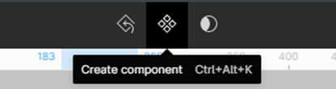

* Create a component.

Price adding button



**Step 5: Variants**

Variants let you group different visual versions of your components into one container. They are component combinations that you can group as a single component set.  Add variants to improve design reality through natural gestures.

Common gestures include pressing, hovering, and clicking when using an application. You can add variants to a component after you have created it. Consider three scenarios when designing a mobile device button: untouched, clicked and disabled. Use the untouched button as the default button.

Do the following:

* Add a variant on the right-side menu when you have clicked the component. Just click the plus icon and name your variants.
* Style the variants by changing the color of the fill, the text color, etc.

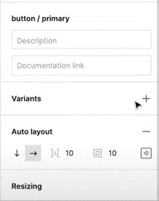

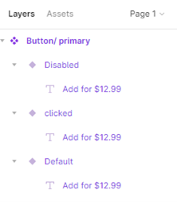

**Step 6: Use the component**

After creating a component, you can use them instantly.

* Drag the component in the *local components*section on the *assets* page to the canvas.

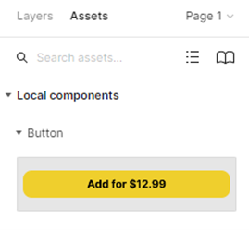

**Step 7: Choose the correct variant**

* Choose the variant corresponding to the circumstances or the conditions of the screen.

